JAVA String Concept

# String Introduction

* String is non premitive data types because it references a memory location where the data is stored in the heap memory or String Constant pool
* It references to a memory whether an object is actually placed
* So that the variable of a non primitive data type is also called the reference data types or object reference variable.
* All non primitive data types are simply called objects which are created by instantiating a class
* String ka size fixed nahi rahta
* String is the squence of the character or array of character

**char**[] ch={'j','a','v','a','t','p','o','i','n','t'};

String s=**new** String(ch);

* Java ke under charSequence name ka interface hota hai jiske vajah se hum char ko represent kar skte hai
* String name ki class java me pahle se hi bani hui hai and uske bahut sare methods pahle se defind hai

**Public final class string extends object**

**{**

**}**

**String class ka syntex hota hai and interview me puchha jata hai ki why string class is final**

* String class ka parent class object hai so voh object class ko inherit karti hai
* String class implements *Serializable*, *Comparable* and *CharSequence* [interfaces](https://www.javatpoint.com/interface-in-java)
* String ek class hone ke vajah se hum uska object bana skte hai

String c = new String();

Jaha c hume ek immutable object bana ke deta hai

* So string is the immutable object
* String create karne ke liye java me 3 classes hai 1) String 2) StringBuffer 3) StringBuilder

# Creating String in Java

* There are two ways to create a string in Java:
* Using String Literal -> String str1 = "Python";
* Using new Keyword-> String str1 = new String ("Java");

# Memory Area in Java

Java ke under 5 type ka areas bane hue hai

1) Method Area

2) Heap Area

3) Stack Area

4) PC Register

5) Native Method Area

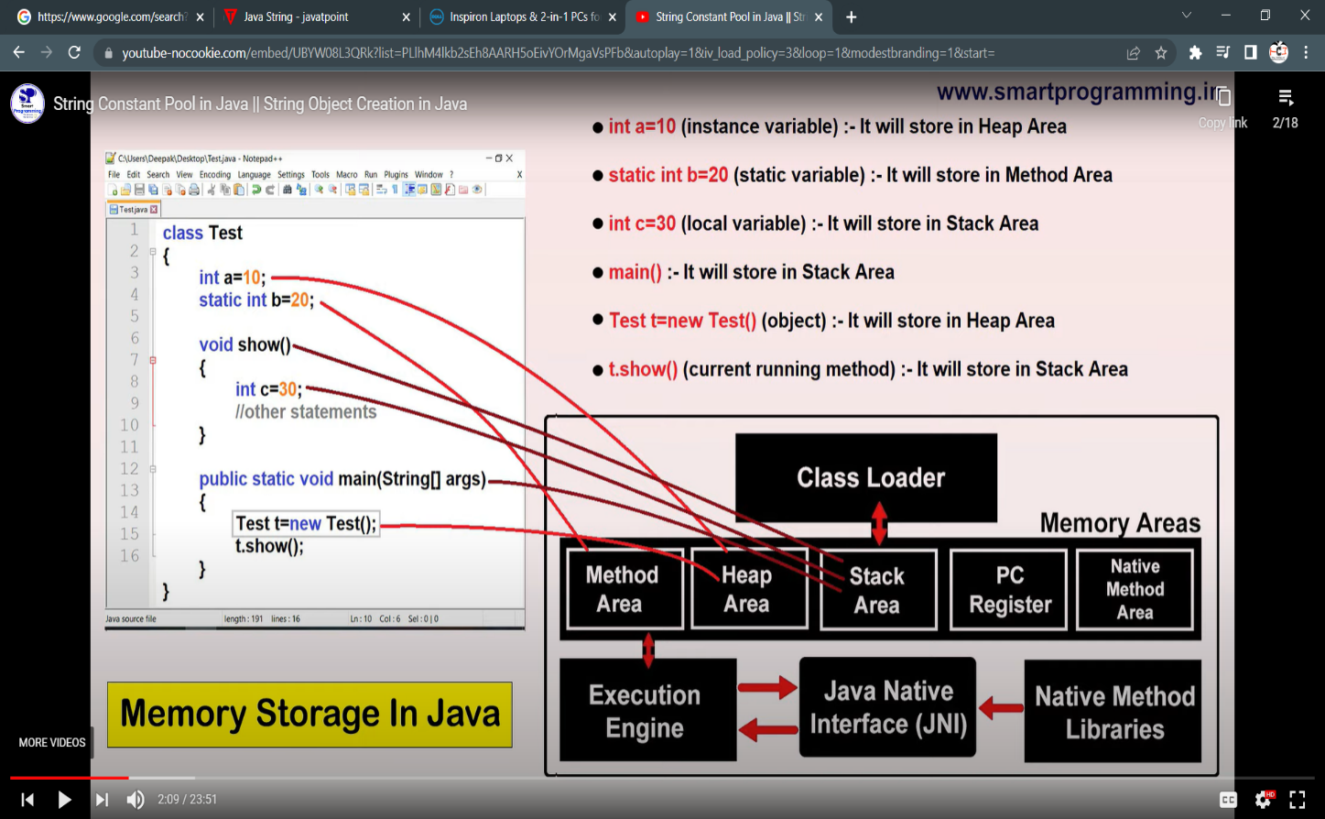

# String Constant Pool

* A “string constant pool” is a separate place in the heap memory where the values of all the strings which are defined in the program are stored.
* 1.6 version tak “scp” method Area me tha but after 1.6 version “scp” ko “heap Area” me transfer kar diya because method area ke ander size fixed rahta hai but heap area me jaise hi scp aaya to voh apne size ko dynamically increase or decrease kar skta hai

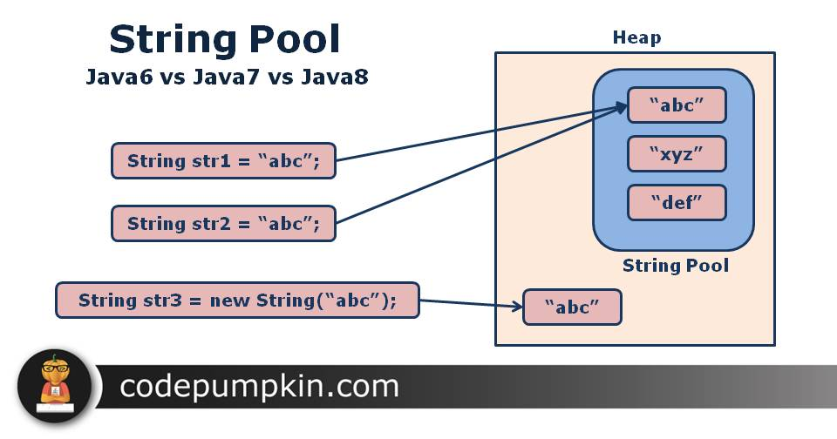

* String a = new String(“Rishikesh”);

Aisa likhne se Rishikesh name ka object heap and String pool dono me create ho jayega

* But String b =”Ram”; likhne se voh sirf String pool me hi create hoga

**Note : new keyword ka use karne par 2 time object create hota hai isliye hum string ko new keyword ki help se jada create nahi karte hai because voh jada memory ocupied karega**

* Heap area ke under Garbage collection ka concept lagta hai but SCP me Garbage collection ka concept nahi lagta because ek baar SCP me object create hota hai to usse hum delete nahi kar skte hai because of “ reference variable” ko internally JVM maintain karta hai

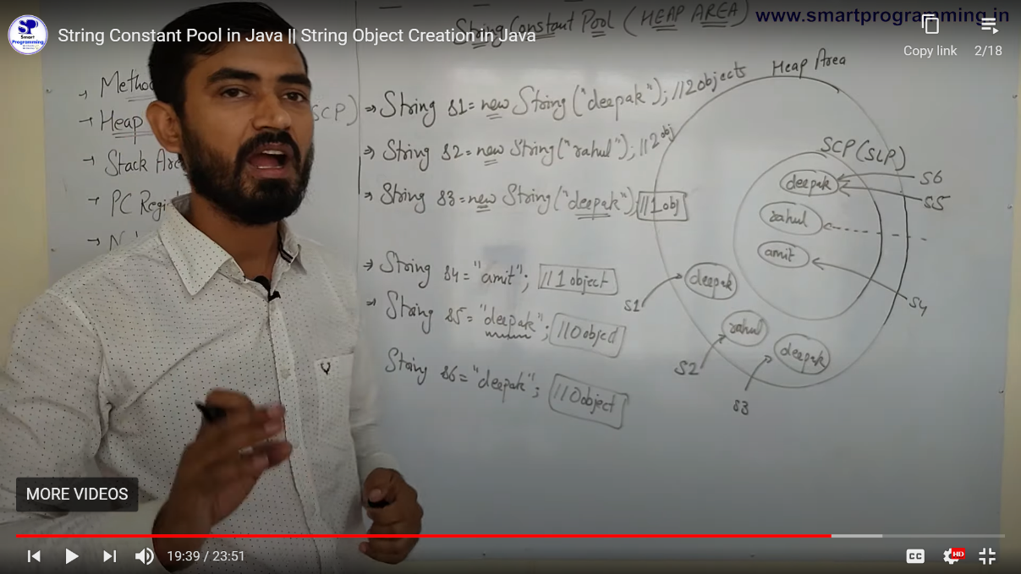

# String Object Are Immutable

* String is immutable which means it cannot be changed. Whenever we change any string, a new instance is created. For mutable strings, you can use StringBuffer and StringBuilder classes.

